Material Modeling
Chapter
3
The Material Modeling package provides product models for common civil engineering materials like concrete and steel. The package also provides analytical modeling services that can be used to predict their stress-strain behavior. Note that the analytical stress-strain models are not directly tied to the material product models, and it is possible to have many stress-strain analytical models for a given material type.

Logical Design
A common base class for material product models was not used since it is unlikely that there will be a situation in which a ‘generic’ material will be useful. In the real world, the type of material an object is made from typically helps to define what the object is. Hence, material type information is something that should be held on to.
Material product models should be used to define a minimum number of properties required to describe the essence of a material. Care should be taken to insure that material product models do not support too much analytical functionality for a given abstraction. A litmus test for this requirement is to ask yourself “can this property take on multiple meanings or implementations for a given material?”. If this is true, it will be best to develop a separate analytical model that provides a family of options. The analytical model may then be used to describe a given behavior for a particular material.
matConcrete is the base class for defining Portland cement concrete materials. The class defines a descriptive name, density, crushing strength f’c, and the elastic modulus E.
matMetal is the base class for defining metallic materials. The class defines a descriptive name, density, elastic modulus, and stress/strain conditions for yield and ultimate limit states.
matPsStrand is a base class for defining different types of prestress strand steels. This class is modeled after the AASHTO M203 specification.
matStressStrainCurve is a pure abstract base class for stress strain analytical models. The primary purpose for this class is to represent stress as a function of strain and to encapsulate the various stress and strain states for a typical material. The class also provides an interface for determination of rupture strains and stresses.
matYieldStressStrainCurve is a pure abstract base class for modeling the stress-strain relationship for materials that have a well-defined yield point and a Young’s modulus which is equal-valued for both tension and compression. Most metals exhibit this type of behavior.
matLinearCurve defines a linear stress-strain curve which essentially just “connects the dots” of the abstract matYieldStressStrainCurve.
The matPsCurve class fits the curve for prestress strands as described in the AASHTO Specifications. A GetStrain() function is required for prestress strands to facilitate calculation of initial strains from jacking forces.

Static Models
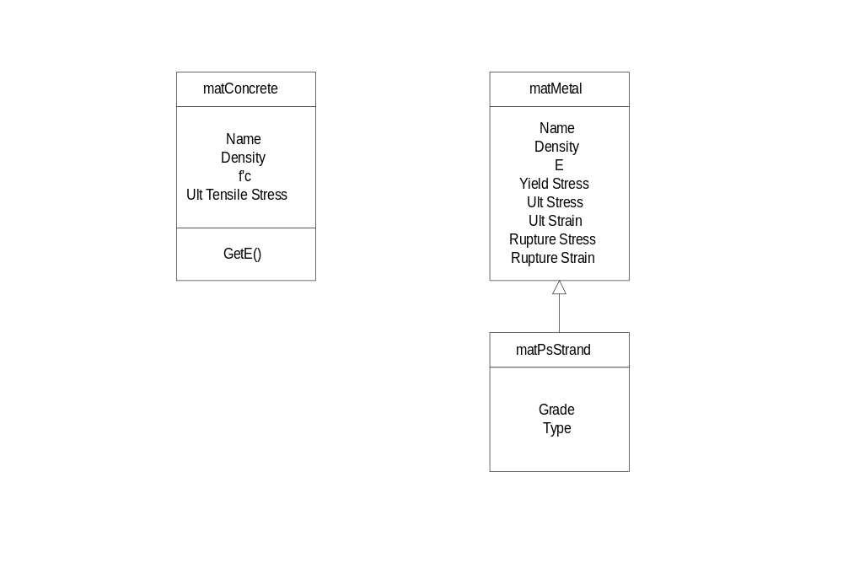
Figure 1
Object Model for Material Product Model Classes
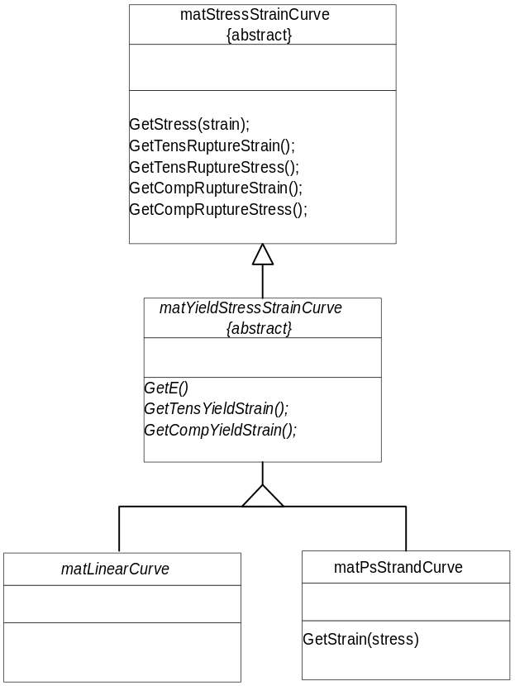
Figure 2
Object Model for Material Stress-Strain Analytical Model.

Dynamic Models

Physical Design
Component | Level | Number of components that must be developed in order to test this component.
N
CCD
ACD
CCD_{Balanced Binary Tree}
NCCD

Specifications
The sign convention used for the material models is compressive stresses and strains are less than zero, tensile stresses and strains are greater than zero.

matConcrete
A base class for Portland Cement concrete material product models.

Public Interface - Member Functions
matConcrete
matConcrete();
Default constructor. Sets name to “Unknown” and density, f’c, and modulus of elasticity to zero.
matConcrete
matConcrete(const std::string& name,
Float64 density,
Float64 fc,
Float64 modE);
Constructs a new material object with name, density, fc, and modE.
matConcrete
matConcrete(const matConcrete& rOther);
Copy constructor.
~matConcrete
virtual ~matConcrete();
Destructor.
operator =
matConcrete& operator=(const matConcrete& rOther);
Assignment operator. Returns reference to self.
SetName
void SetName(const std::string& name);
Assigns a new name to the material model.
GetName
std::string GetName() const;
Returns the name of the material model.
SetDensity
void SetDensity(Float64 density);
Sets the density of the material to density.
GetDensity
Float64 GetDensity() const;
Returns the density of the material.
SetFc
void SetFc(Float64 fc);
Sets the unconfined crushing strength of the material to fc.
GetFc
Float64 GetFc() const;
Returns the unconfined crushing strength of the material.
SetE
void SetE(Float64 modE);
Sets the modulus of elasticity.
GetE()
virtual Float64 GetE() const;
Returns the elastic modulus for the concrete.
RegisterListener
void RegisterListener(matConcreteListener* pListener);
Registers a concrete material listener with this object. Listeners are notified via the matConcreteListener interface whenever the concrete material properties are modified.
UnregisterListener
void UnregisterListener(matConcreteListener* pListener);
Unregisters a listener from this object. The listener will no longer receive event notifications from this object. If the supplied listener was not previously registered with this object, this function does nothing (however, the debugging version issues a WARN message).
CreateClone
virtual matConcrete* CreateClone() const;
Creates a clone of the material.

matConcreteListener
Provides a callback interface for concrete material observers. When a concrete material changes, a listener is notified through the callback methods in this interface. Each callback is implemented with a do-nothing function. Subclass need only override those events they are interested in listening to.

Public Interface - Member Functions
matConcreteListener
matConcreteListener();
Default constructor.
OnConcreteChanged
virtual void OnConcreteChanged(matConcrete& concrete);
Called by concrete whenever it changes.

matMetal
A base class for metallic material product models.

Public Interface - Member Functions
matMetal
matMetal();
Default constructor. Sets name to “Unknown” and all properties set to zero.
matMetal
matMetal(const std::string& name, Float64 density, Float64 E, Float64 yieldStress, Float64 ultStress, Float64 ultStrain, Float64 ruptureStress, Float64 ruptureStrain);
Constructs a new material object with name, density, E, yieldStress, ultStress, ultStrain, ruptureStress, and ruptureStrain.
matMetal
matMetal(const matMetal& rOther);
Copy constructor.
~matMetal
virtual ~matMetal();
Destructor.
operator =
matMetal& operator=(const matMetal& rOther);
Assignment operator. Returns reference to self.
SetName
void SetName(const std::string& name);
Assigns a new name to the material model.
GetName
std::string GetName() const;
Returns the name of the material model.
SetDensity
void SetDensity(Float64 density);
Sets the density of the material to density.
GetDensity
Float64 GetDensity() const;
Returns the density of the material.
SetE
void SetE(Float64 E);
Sets the elastic modulus for the material.
GetE
Float64 GetE() const;
Returns the elastic modulus for the material.
SetYieldStress
void SetYieldStress(Float64 yieldStress);
Sets the yield stress of the material to yieldStress.
GetYieldStress
Float64 GetYieldStress() const;
Returns the yield stress of the material.
GetYieldStrain
Float64 GetYieldStrain() const;
Returns the yield strain of the material. The yield strain is computed as the yield stress divided by the modulus of elasticity.
SetUltStress
void SetUltStress(Float64 ultStress);
Sets the ultimate stress of the material to ultStress.
GetUltStress
Float64 GetUltStress() const;
Returns the ultimate stress of the material.
SetUltStrain
void SetUltStrain(Float64 ultStrain);
Sets the ultimate strain of the material to ultStrain.
GetUltStrain
Float64 GetUltStrain() const;
Returns the ultimate strain of the material.
SetRuptureStress
void SetRuptureStress(Float64 ruptureStress);
Sets the rupture stress of the material to ruptureStress.
GetRuptureStress
Float64 GetRuptureStress() const;
Returns the rupture stress of the material.
SetRuptureStrain
void SetRuptureStrain(Float64 ruptureStrain);
Sets the rupture strain of the material to ruptureStrain.
GetRuptureStrain
Float64 GetRuptureStrain() const;
Returns the rupture strain of the material.
RegisterListener
void RegisterListener(matMetalListener* pListener);
Registers a concrete material listener with this object. Listeners are notified via the matMetalListener interface whenever the concrete material properties are modified.
UnregisterListener
void UnregisterListener(matMetalListener* pListener);
Unregisters a listener from this object. The listener will no longer receive event notifications from this object. If the supplied listener was not previously registered with this object, this function does nothing (however, the debugging version issues a WARN message).
CreateClone
virtual matMetal* CreateClone() const;
Creates a clone of the material.

matMetalListener
Provides a callback interface for metallic material observers. When the material changes, a listener is notified through the callback methods in this interface. Each callback is implemented with a do-nothing function. Subclass need only override those events they are interested in listening to.

Public Interface - Member Functions
matMetalListener
matMetalListener();
Default constructor.
OnMetalChanged
virtual void OnMetalChanged(matMetal& metal);
Called by metal whenever it changes.

matPsStrand
An concrete class for prestress strand steel product models. The interface for this class is identical to the matMetal class except for addition of the grade and strand steel type. The following functions are added/changed. This product model is modeled after the AASHTO M203 specification for prestressing strands.

Public Interface - Member Functions
matPsStrand
matPsStrand();
Default constructor. Sets name to “Unknown”, strand grade to Gr250 and strand type to LowRelaxation.
matPsStrand
matPsStrand(const std::string& name,
Grade grade,
Type type,
Float64 fpu,
Float64 fpy,
Float64 modE,
Float64 d,
Float64 a,
Int16 maxSlope);
Constructs a new material object with the supplied parameters.
SetGrade
void SetGrade(Grade grade);
Sets the strand grade of the material to grade.
GetGrade
Grade GetGrade() const;
Returns the strand grade of the material.
SetType
void SetType(Type type);
Sets the strand type of the material to type.
GetType
Type GetType() const;
Returns the strand type of the material.
SetFpu
void SetFpu(Float64 fpu);
Sets the ultimate strength of the strand.
GetFpu
Float64 GetFpu() const;
Returns the ultimate strength of the strand.
SetFpy
void SetFpy(Float64 fpy);
Sets the yield strength of the strand.
GetFpy
Float64 GetFpy() const;
Returns the yield strength of the strand.
SetE
void SetE(Float64 e);
Sets the modulus of elasticity of the strand.
GetE
Float64 GetE() const;
Returns the modulus of elasticity of the strand.
SetNominalDiameter
void SetNominalDiameter(Float64 nd);
Sets the nominal diameter of the strand.
GetNominalDiameter
Float64 GetNominalDiameter() const;
Returns the nominal diameter of the strand.
SetNominalArea
void SetNominalArea(Float64 na);
Sets the nominal area of the strand.
GetNominalArea
Float64 GetNominalArea() const;
Returns the nominal area of the strand.
SetMaxSlope
void SetMaxSlope(Int16 maxSlope);
Sets the maximum slope of the strand. Strand slope is defined in the form 1:maxSlope.
GetMaxSlope
Int16 GetMaxSlope() const;
Returns the maximum slope of the strand.

Public Interface - Enumerations
Grade
enum Grade { Gr250,
Gr270
};
Strand grades.
Type
enum Type { LowRelaxation,
StressRelieved
};
Strand types.

matRebar
An concrete class for mild steel reinforcement (rebar) product models. Reinforcement bars shapes may be circular or square. The interface for this class is identical to the matMetal class except for addition of the shape type, nominal dimension, and area. The following functions are added/changed.

Public Interface - Member Functions
matRebar
matRebar();
Default constructor. Sets name to “Unknown”, shape to Circle and all other material properties to zero.
matRebar
matRebar(const std::string& name,
Float64 fpu,
Float64 fpy,
Float64 modE,
ShapeType shape,
Float64 dim,
Float64 area);
Constructs a new material object with the supplied parameters.
matRebar
matRebar(const matRebar& rOther);
Copy constructor.
operator=
matRebar& operator=(const matRebar& rOther);
Assignment operator.
SetShapeType
void SetShapeType(ShapeType st);
Sets the shape type of the bar.
GetShapeType
ShapeType GetShapeType() const;
Returns the shape type of the bar.
SetNominalDimension
void SetNominalDimension(Float64 nd);
Sets the nominal dimension of the bar (Diameter if round bar, height if square bar).
GetNominalDiameter
Float64 GetNominalDimension() const;
Returns the nominal dimension of the bar.
SetNominalArea
void SetNominalArea(Float64 na);
Sets the nominal area of the bar.
GetNominalArea
Float64 GetNominalArea() const;
Returns the nominal area of the bar.

Public Interface - Enumerations
ShapeType
enum ShapeType { Circle,
Square
};
Rebar shapes.

matCrsiRebarPool
A utility class for accessing instances of matRebar based on size and grade. The product model is modeled after the CRSI specification for reinforcing bars as shown in the following tables.
Bar Sizes - Soft Metric
 |  |  | Nominal Dimensions
Bar  Designation | Nominal  Mass | Diameter | Cross  Sectional  Area | Perimeter
No. | kg/m | mm | mm² | mm
10 | 0.560 | 9.5 | 71 | 29.9
13 | 0.994 | 12.7 | 129 | 39.9
16 | 1.552 | 15.9 | 199 | 49.9
19 | 2.235 | 19.1 | 284 | 59.8
22 | 3.042 | 22.2 | 387 | 69.8
25 | 3.973 | 25.4 | 510 | 79.8
29 | 5.060 | 28.7 | 645 | 90.0
32 | 6.404 | 32.3 | 819 | 101.3
36 | 7.907 | 35.8 | 1006 | 112.5
43 | 11.38 | 43.0 | 1452 | 135.1
57 | 20.24 | 57.3 | 2581 | 180.1

Bar Sizes - US
 |  |  | Nominal Dimensions
Bar  Designation | Nominal  Weight | Diameter | Cross  Sectional  Area | Perimeter
No. | lb/ft | in. | in.² | in.
3 | 0.376 | 0.375 | 0.11 | 1.178
4 | 0.668 | 0.500 | 0.20 | 1.571
5 | 1.043 | 0.625 | 0.31 | 1.963
6 | 1.502 | 0.750 | 0.44 | 2.356
7 | 2.044 | 0.875 | 0.60 | 2.749
8 | 2.670 | 1.000 | 0.79 | 3.142
9 | 3.400 | 1.128 | 1.00 | 3.544
10 | 4.303 | 1.270 | 1.27 | 3.990
11 | 5.313 | 1.410 | 1.56 | 4.430
14 | 7.650 | 1.693 | 2.25 | 5.320
18 | 13.60 | 2.257 | 4.00 | 7.090

MakeRebar
static const matRebar& GetRebar(Grade grade, RebarSize size);
Returns a reference to a matRebar object. The properties of the rebar object change as system unit change. The name of the rebar object is in the form of “Grade 75 - #10(SI/US)”.

Public Interface - Enumerations
Grade
enum Grade { Gr60, Gr75,
Gr420, Gr520
};
Bar grades.
Type
enum Size {
SI10, SI13, SI16, SI19, SI22, SI25, SI29, SI32,
SI36, SI43, SI57,
US3, US4, US5, US6, US7, US8, US9, US10, US11,
US14, US18
};
Rebar sizes (SI = “SI (Metric)”. US = “Customary US Units (English)”).

matStressStrainCurve
An pure abstract base class for material stress strain analytical models.
matStressStrainCurve
matStressStrainCurve();
Constructs a new matStressStrainCurve object with name = “Unknown”, and all stresses and strains equal to zero.
matStressStrainCurve
matStressStrainCurve(const std::string& name,Float64 tensRuputureStress, Float64 tensRuputureStrain, Float64 compRuputureStress, Float64 compRuputureStrain);
Constructs a new matStressStrainCurve object with name, and rupture stress and strain values.
matStressStrainCurve
matStressStrainCurve(const matStressStrainCurve& rOther);
Copy constructor.
~matStressStrainCurve
virtual ~matStressStrainCurve();
Destructor.
operator =
matStressStrainCurve& operator=(const matStressStrainCurve& rOther);
Assignment operator. Returns reference to self.
CreateClone
virtual matStressStrainCurve * CreateClone() const =0;
Creates a polymorphic type-safe clone of this curve.
SetName
void SetName(const std::string& name);
Assigns a new name to the stress-strain model.
GetName
std::string GetName() const;
Returns the name of the stress-strain model.
GetStress
virtual matStressStrainCurve::StrainState GetStress(Float64 e,
Float64* s) const = 0;
Given the strain e, computes the stress s. Returns the strain state of the material for the given strain level. If the return value is TensileFractured or CompressionFractured, s is undefined. Throws a matXStressStrainEvalError exception if an error occurs when evaluating the stress strain curve.
SetRuptureStress
void SetRuptureStess(Float64 stress, StrainType type);
Sets the rupture stress for the stress-strain curve.
GetRuptureStress
Float64 GetRuptureStress( StrainType type) const;
Returns the rupture stress for the stress-strain curve.
SetRuptureStrain
void SetRuptureStrain(Float64 strain, StrainType type);
Sets the rupture strain for the stress-strain curve.
GetRuptureStrain
Float64 GetRuptureStrain(StrainType type) const;
Returns the rupture strain for the stress-strain curve.

Protected Interface - Member Functions
ThrowStressStrainEvalException
void ThrowEvalException(const char* msg,Float64 offendingStrain,matXStressStrainEvalError::Reason reason);
Throws an matXStressStrainEvalError exception. Subclass should call this method when GetStress() cannot return a valid value.

Public Interface - Enumerations
StrainState
enum StrainState { Elastic, // Material is in the elastic range
Plastic, // Material has yielded, but not
// fractured
TensileFractured
CompressionFractured
};
Defines the various strain states of a material.
StrainType
enum StrainType { Tension
Compression
};
Defines whether material is in tension or compression.

matYieldStressStrainCurve
An pure abstract base class for stress strain analytical models that exhibit a defined elastic region and yield points.
matYieldStressStrainCurve
matYieldStressStrainCurve();
Constructs a new matYieldStressStrainCurve object with name = “Unknown”, and all stresses and strains equal to zero.
matYieldStressStrainCurve
matYieldStressStrainCurve(const std::string& name, Float64 E, Float64 tensYieldStress, Float64 compYieldStress, Float64 tensUltStress, Float64 tensUltStrain, Float64 compUltStress, Float64 compUltStrain, Float64 tensRuptureStress, Float64 tensRuptureStrain, Float64 compRuptureStress, Float64 compRuptureStrain);
Constructs a new matYieldStressStrainCurve object with name, and rupture stress and strain values.
matYieldStressStrainCurve
matYieldStressStrainCurve(const matYieldStressStrainCurve& rOther);
Copy constructor.
~matYieldStressStrainCurve
virtual ~matYieldStressStrainCurve();
Destructor.
operator =
matYieldStressStrainCurve& operator=(const matYieldStressStrainCurve& rOther);
Assignment operator. Returns reference to self.
SetE
void SetE(Float64 e);
Set Young’s modulus for the stress-strain curve
GetE
Float64 GetE() const;
Return Young’s modulus for the stress-strain curve.
SetYieldStress
void SetYieldStess(Float64 stress, StrainType type);
Sets the yield stress for the stress-strain curve.
GetYieldStress
Float64 GetYieldStress(StrainType type) const;
Returns the yield stress for the stress-strain curve.
GetYieldStrain
Float64 GetYieldStrain() const;
Returns the yield strain of the material. The yield strain is computed as the yield stress divided by the modulus of elasticity.
matLinearCurve
A concrete class for implementing linear approximation for stress strain curves. The stress-strain curve for this type basically just “connects the dots” of the matYieldStressStrainCurve.
matLinearCurve
matLinearCurve();
Default constructor. Sets name to “Unknown” and all properties set to zero.
matLinearCurve
matLinearCurve(const std::string& name, Float64 E, Float64 tensYieldStress, Float64 compYieldStress, Float64 tensUltStress, Float64 tensUltStrain, Float64 compUltStress, Float64 compUltStrain, Float64 tensRuptureStress, Float64 tensRuptureStrain, Float64 compRuptureStress, Float64 compRuptureStrain);
Constructs a new linear stress-strain curve object with name, E, tensYieldStress ,compYieldStress, TensUltStress tensUltStrain, compUltStress, compUltStrain, tensRuptureStress, tensRuptureStrain, compRuptureStress, and compRuptureStrain.
matLinearCurve
matLinearCurve(const matMetal& rMetal);
Constructs a new stress strain curve object with a reference to a matMetal object. The curve is given the same name as the material.
Note: In order to avoid unnecessary dependencies, care should be taken when implementing this function to refer to matMetal by name only in the header file.
matLinearCurve
matLinearCurve(const matLinearCurve& rOther);
Copy constructor.
~matLinearCurve
virtual ~matLinearCurve();
Destructor.
operator =
matLinearCurve& operator=(const matLinearCurve& rOther);
Assignment operator. Returns reference to self.
GetStress
virtual matStressStrainCurve::StrainState GetStress(Float64 e,
Float64* s) const;
Given the strain e, computes the stress s using linear interpolation. Returns the strain state of the material for the given strain level. If the return value is TensileFractured or CompressionFractured, s is undefined.

matPsStrandCurve
An concrete class for prestress strand steel stress-strain analytical models. The interface for this class is identical to the matYieldStressStrainCurve class except for the constructor and the addition of a GetStrain() function. This function is necessary to back initial strains out from strand stress or jacking force.

matPsStrandCurve
matPsStrandCurve( const matPsStrand& strand);
Construct a prestress stress-strain curve based on a given prestressed material.
GetStrain
virtual matStressStrainCurve::StrainState GetStrain(Float64 s Float64* e) const;
Given the stress s, computes the strain e. Returns the strain state of the material for the given strain level. If the return value is TensileFractured or CompressionFractured, s is undefined.

matXStressStrainEvalError
Exception class for stress-strain curves. This class is thrown when an attempt is made to evaluate an ill-formed stress strain curve. (e.g. stresses are not single-valued). matStressStrainCurve is a friend of this class and the constructor for this class is private. Instances of this class can only be created by matStressStrainCurve through its protected interface.

Private Interface - Constructor.
matXStressStrainEvalError
matXStressStrainEvalError (const char* message, Float64 offendingStrain, Reason reason);
Constructor

Public Interface - Member Functions
matXStressStrainEvalError
matXStressStrainEvalError(const matXStressStrainEvalError& rOther);
Copy constructor
GetOffendingStrain
Float64 GetOffendingStrain() const;
Returns the strain the caused the evaluation error.
GetReason
matXStressStrainEvalError::Reason GetReason() const;
Returns the reason for the evaluation error.

Public Interface - Enumerations
Reason
enum Reason {
Unknown, // An unknown error occurred
MultiValuedStress // Stress is multi-valued
};
Returns the reason for the evaluation error.
No longer needed

